**SDK Development Guide**

1. **Source code and SDK installation**

The source code locate in

$/EM/Encompass/Development/v17.1/EMLite/EncompassAPI

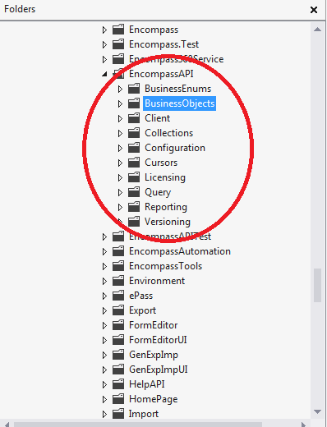

For initial installation for SDK, you can find spec SDKProgrammersGuide.pdf in $/EM/Encompass/Project/Encompass15.1SdkTest/EMLite/SDKRes/Docs

1. **Setup developing environment**

Before development, please run “Register Encompass SDK” from admin Tools. (The register code is AAAAPCKTFS. )

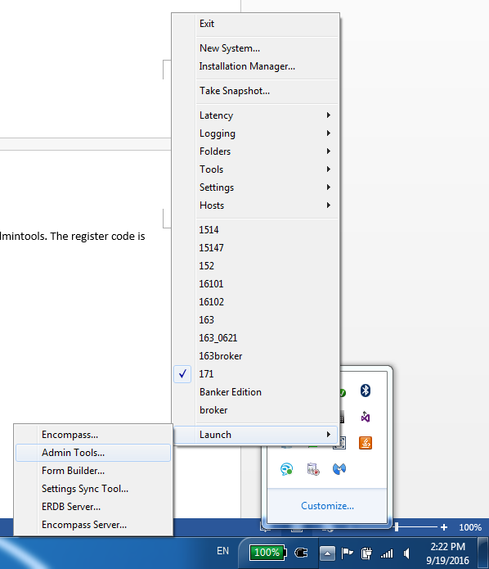

After SDK register you can test your SDK with your test APP on local machine.

We have a test platform for QA where developer can add their API testing. The test platform source code located in “$/EM/Encompass/Project/Encompass15.1SdkTest”. When you finished your SDK development, you can add your test interface in this project for QA testing. (This is a web app using Microsoft MVC framework. it need IIS installed on your local environment)

1. **Development**
2. Add public interface in project “EncompassAPI”
3. Add new method which you want to publish to customer in interface file
4. Implement the method in the class which inherit from the interface
5. Implement the data in the public class which will transfer data to user.

Example($/EM/Encompass/Development/v17.1/EMLite/EncompassAPI/BusinessObjects/TradeManagement/MasterContractService.cs):

/// <summary>

/// Get a list of <see cref="SecurityTradeObject"/> by security trade status

/// </summary>

/// <param name="tradeStatus"><see cref="SecurityTradeStatus"/>List</param>

/// <returns>A list of <see cref="List<SecurityTradeObject>"/></returns>

/// <remarks>

/// Example 1: Get all active loan trades

/// SecurityTradeStatus[] statusList = new TradeStatus[] { MasterCommitmentStatus.Active};

/// EllieMae.Encompass.Client.Session session = Session["EncompassSession"] as EllieMae.Encompass.Client.Session;

/// var ActiveLoanTrades = session.MasterContractService.GetMasterTradeByStatus(statusList);

/// Example 2: Get all archived loan trades

/// SecurityTradeStatus[] statusList = new TradeStatus[] { MasterCommitmentStatus.Archived };

/// EllieMae.Encompass.Client.Session session = Session["EncompassSession"] as EllieMae.Encompass.Client.Session;

/// var ActiveLoanTrades = session.MasterContractService.GetMasterTradeByStatus(statusList);

/// Example 3: Get all loan trades

/// EllieMae.Encompass.Client.Session session = Session["EncompassSession"] as EllieMae.Encompass.Client.Session;

/// var ActiveLoanTrades = session.MasterContractService.GetMasterTradeByStatus();

/// </remarks>

public List<MasterContract> GetMasterTradeByStatus(MasterCommitmentStatus[] tradeStatus = null)

{

List<MasterContract> rtnValue = new List<MasterContract>();

int[] status;

if (tradeStatus == null)

{

status = new int[2] { (int)MasterCommitmentStatus.Active, (int)MasterCommitmentStatus.Archived };

}

else

{

status = new int[tradeStatus.Length];

for (int i = 0; i < tradeStatus.Length; i++)

{

status[i] = (int)tradeStatus[i];

}

}

if(status.Contains((int)MasterCommitmentStatus.Active))

{

MasterContractSummaryInfo[] masterContracts = mngr.GetActiveContracts(true);

for (int i = 0; i < masterContracts.Length; i++)

{

rtnValue.Add(new MasterContract(masterContracts[i]));

}

}

if (status.Contains((int)MasterCommitmentStatus.Archived))

{

MasterContractSummaryInfo[] masterContracts = mngr.GetArchivedContracts(true);

for (int i = 0; i < masterContracts.Length; i++)

{

rtnValue.Add(new MasterContract(masterContracts[i]));

}

}

In this Example, we need add a method in file IMasterContractService.cs, implement data contract in file MasterContract.cs.

1. Test new interface on test platform

To test the example method, you need add reference EncompassObjects.dll on test app then you can call the published methods from test app.

Code example (MasterContractController.cs in project Encompass15.1SdkTest):

EllieMae.Encompass.Client.Session session = Session["EncompassSession"] as EllieMae.Encompass.Client.Session;

List<EllieMae.Encompass.BusinessObjects.TradeManagement.MasterContract> contracts = session.MasterContractService.GetMasterTradeByStatus();

model.QualifiedContracts = contracts;